Бурт

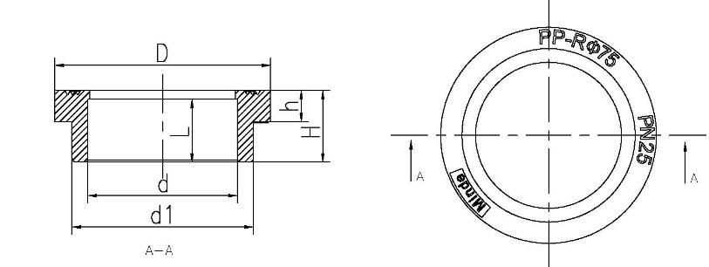

№ | Размер | D | d | d1 | L | H | h | Вес
1 | Ø 40 | 76.8 | 39.3 | 50 | 21.5 | 26.7 | 11.2 | 45
2 | Ø 50 | 86.3 | 49.3 | 60.5 | 24.6 | 29.4 | 12.8 | 62
3 | Ø 63 | 87.8 | 62.2 | 73.1 | 27.3 | 34.7 | 14.7 | 70
4 | Ø 75 | 105 | 74 | 88.3 | 30.6 | 35.3 | 15.2 | 91
5 | Ø 90 | 122.3 | 88.8 | 106.6 | 34.8 | 39.4 | 16.8 | 142
6 | Ø 110 | 149.5 | 108.5 | 130.8 | 35.4 | 43 | 18 | 231
7 | Ø 125 | 190 | 123,2 | 149,2 | 40 | 63,3 | 22,5 | 590
8 | Ø 160 | 218 | 157 | 184 | 40 | 75 | 27.5 | 960

