
EMAS ELEKTROTEKNİK MAKİNA SANAYİ VE TİCARET A.Ş

Ziya Gökalp Mah. İkitelli Organize Sanayi Bölgesi Atatürk Bulvarı No:50 34490 Başakşehir / İstanbul / TÜRKİYE
Telefon : +90 212 549 22 52
Faks : +90 212 549 25 80
Web : www.emasas.com.tr

Technical Specifications : MK1MİM2

Order Code:

MK1MİM2
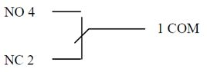
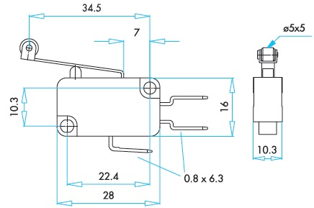
Contact Sheme:

Technical Information :
-1 changeover contact
-Short hinge lever type end unit

Body:
General Specifications :

Electrical Informations :
Standards:

-TS EN 60947-5-1


-Compact and precise operation
-Long life time
-High contact reliability

-Operating Temperature | -5 / +125 °C
-Mechanical life | 10.000.000 (3600 op/hour)
-Electrical life | 100.000 (900 op/hour)
-Protection degree | IP20

General Specifications :

-Range of use |  | AC15-AC3
-Operating frequency | f | 50 Hz
-Operating voltage | Ue | 250 V AC
-Operating current | Ie | 10 (4) A
-Insulation voltage | Ui | 660 V
-Stroke resistance voltage | Uimp | 2,5 kV
-Short circuit breaking capacity | Icn | 1 kA
-Insulation Resistance |  | 10 MΩ (500 V DC)

