
EMAS ELEKTROTEKNİK MAKİNA SANAYİ VE TİCARET A.Ş

Ziya Gökalp Mah. İkitelli Organize Sanayi Bölgesi Atatürk Bulvarı No:50 34490 Başakşehir / İstanbul / TÜRKİYE
Telefon : +90 212 549 22 52
Faks : +90 212 549 25 80
Web : www.emasas.com.tr

Technical Specification : PSA040AK441E

Order Code :
PSA040AK441E
-4 poles, on-off cam switches.

Contact and Assembly Schema :

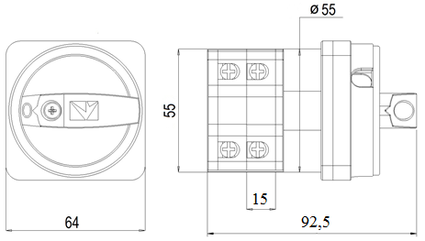

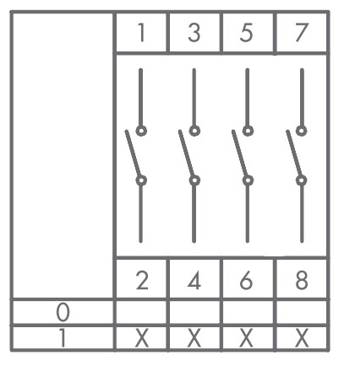
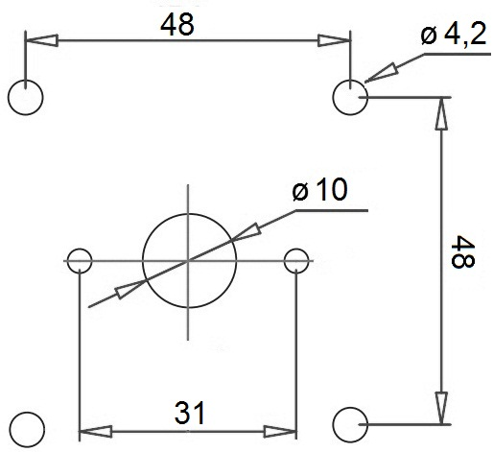
Body :
General Specification:

General Specification :

Electrical Informations :
Standards :

-TS EN 60947-3



-High precision
-Long life time
-High contact reliability
-Compact design
-Handle designed in comformity with finger ergonomy

-Operating Temparature | -5 / +40 °C
-Mechnical Life | 100.000 (900 op/hour)
-Electrical Life | 50.000 (450 op/hour)
-Protection Degree | IP20 outside board  IP54 inside board  IP65 inside box

-Range of use |  | AC1 / AC21
-Operating Voltage | Ue | 400 V
- Fregquency |  | 50 Hz
-Termal current | Ith | 50A
- Operating Current | Ie | 40A
- Insulation voltage | Ui | 690 V
- Stroke resistance voltage | Uimp | 4 kV
- Short circuit breaking capacity | Icn | 6 kA
- Insulation Resistance |  | min 10MΩ

Technical Information :

