
EMAS ELEKTROTEKNİK MAKİNA SANAYİ VE TİCARET A.Ş

Ziya Gökalp Mah. İkitelli Organize Sanayi Bölgesi Atatürk Bulvarı No:50 34490 Başakşehir / İstanbul / TÜRKİYE
Telefon : +90 212 549 22 52
Faks : +90 212 549 25 80
Web : www.emasas.com.tr

Technical Specifications : MB200DH

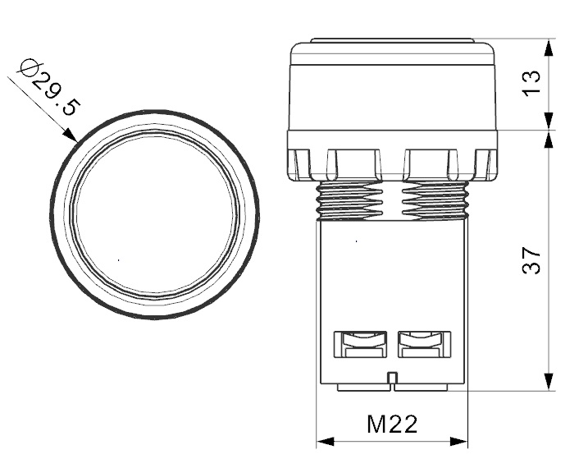
Order Code:
MB200DH
Contact Block:
1NC
Terminals with finger protection.
Mono block body.
Protective cable inlet tips enabling maximum safety.
Screw Washers..

Technical Information :

Body:
Plastic body.
Opportunity of positioning with plates and Badge Bases.
General Specifications
Operating Temparature | -5/+40°C
Mechanical life | 0,5 Million (3000 open-close/hour)
Electrical Life | 0,1 Million (1800 open-close/hour)
C.Block Tightening Torque | 0,5-0,6 Nm
C.Block Connection Wire Profile | Min: 1x0,5 mm'2 / Max: 2x2,5 mm'2
Protection Degree | IP40

Electrical Informations :
General Specifications
Range Of Use |  | AC15
Operating Voltage | Ue | 230V AC
Fregquency | F | 50Hz
Operating Current | Ie | 4A
Insulation Resistance | Ui | 300V
Stroke Resistance Voltage | Uimp | 2.5kV
Dielectrical Strength |  | 1500V AC

General Specifications
Range Of Use |  | AC14
Operating Voltage | Ue | 240V AC
Fregquency | f | 50Hz
Operating Current | Ie | D300
Insulation Resistance | Ui | 250V

Electrical Informations :
Standards:

- TS EN 60947 -5-1

In Contact Blocks;

