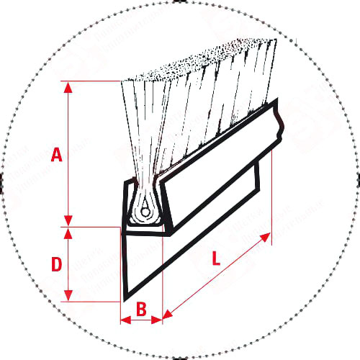

L=1000mm
B=2.5mm
A=20mm
D=21mm

