**Demolition Breaker**

**Demolition Breaker**

EN

***PDB15006 PDB15006-9***

***PDB15006M PDB15006-6***

***UPDB15006 PDB15006S***

***PDB15006-4 PDB15006-8***

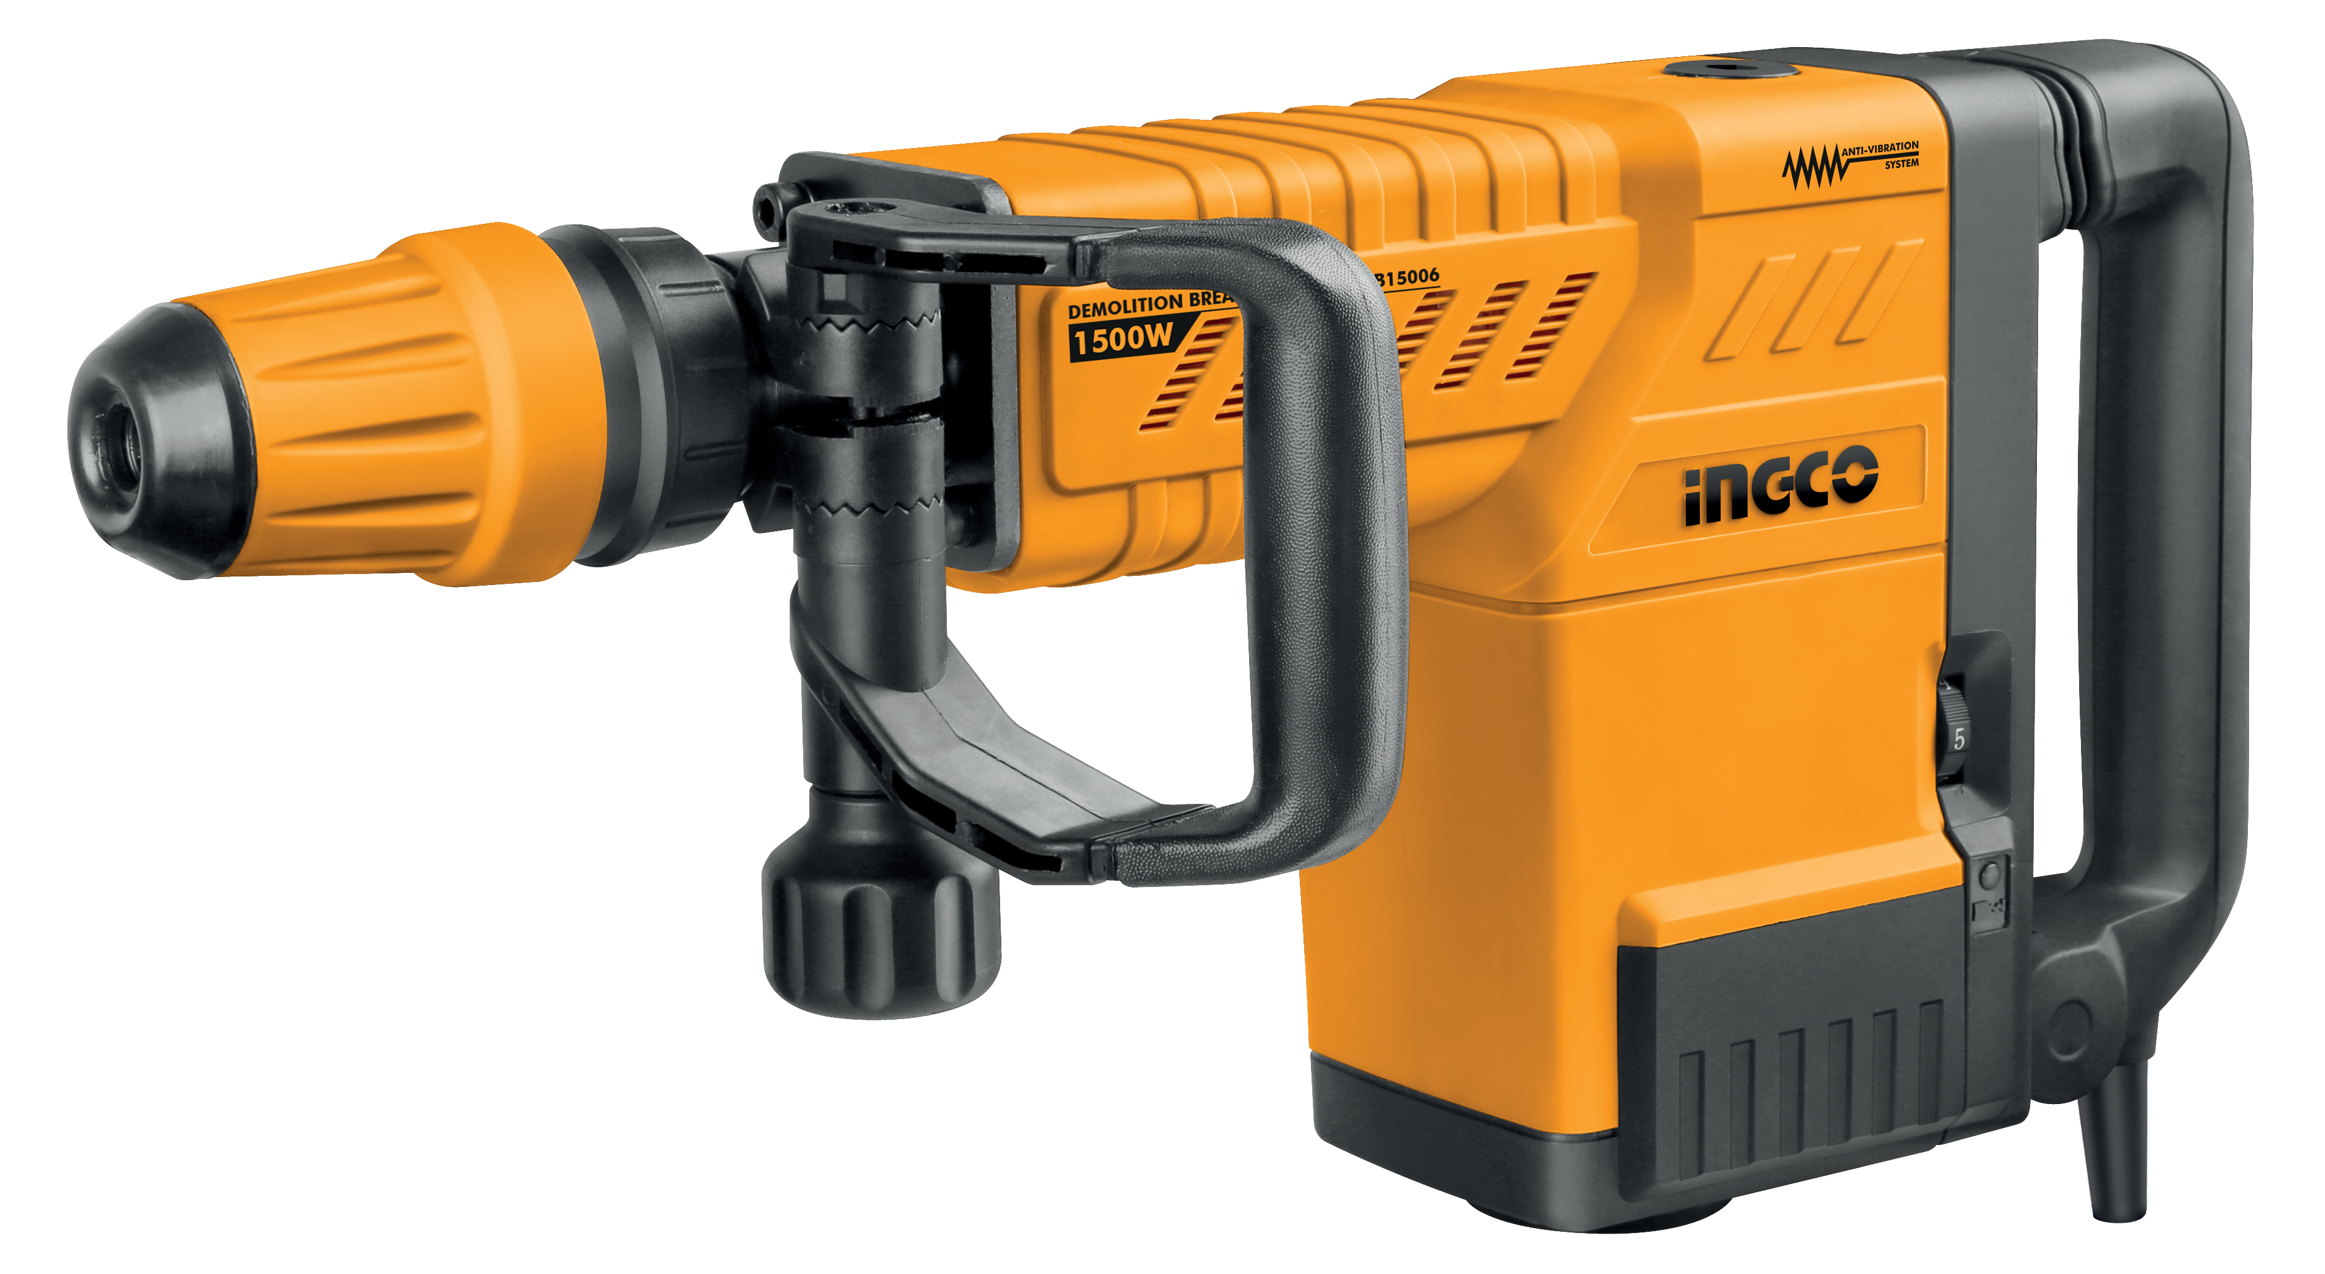

## ingcoglobal

#### INGCO GLOBAL

**SCAN FOR VIDEO**

**The symbols in instruction manual and the label on the tool**

|  |  |
| --- | --- |
|  | Double insulated for additional protection. |
|  | Read the instruction manual before using. |
|  | CE conformity. |
|  | Wear safety glasses, hearing protection and dust mask. |
|  | Waste electrical products should not be disposed of with household waste. Please recycle where facilities exist. Check with your Local Authority or retailer for recycling advice. |
|  | Safety alert.  Please only use the accessories supported by the manufacture. |



**WARNING Read all safety warnings and all instructions**. *Failure to*

**GENERAL POWER TOOL SAFETY WARNINGS**

*follow the warnings and instructions may result in electric shock, fire and/or*

*serious injury*.

**Save all warnings and instructions for future reference.**

*The term "power tool" in the warnings refers to your mains-operated (corded) power tool or battery-operated (cordless) power tool.*

1. **Work area safety**
   1. **Keep work area clean and well lit.** *Cluttered and dark areas invite accidents.*
   2. **Do not operate power tools in explosive atmospheres, such as in the presence of flammable liquids, gases or dust.** *Power tools create sparks which may ignite the dust or fumes.*
   3. **Keep children and bystanders away while operating a power tool.** *Distractions can cause you to lose control.*
2. **Electrical safety**
   1. **Power tool plugs must match the outlet. Never modify the plug in any way. Do not use any adapter plugs with earthed (grounded) power tools.** *Unmodified plugs and matching outlets will reduce risk of electric shock.*
   2. **Avoid body contact with earthed or grounded surfaces such as pipes, radiators, ranges and refrigerators.** *There is an increased risk of electric shock if your body is earthed or grounded.*
   3. **Do not expose power tools to rain or wet conditions.** *Water entering a power tool will increase the risk of electric shock.*
   4. **Do not abuse the cord. Never use the cord for carrying, pulling or unplugging the power tool. Keep cord away from heat, oil, sharp edges or moving parts.** *Damaged* or *entangled* cords *increase the risk of electric shock.*
   5. **When operating a power tool outdoors, use an extension cord suitable for outdoor use.** Use of a *cord suitable for outdoor use reduces the risk of electric shock.*

##### If operating a power tools in a damp location is unavoidable, use

**a residual current device (RCD) protected supply.** *Use of an RCD reduces the risk of electric shock.*

##### Personal safety

* 1. **Stay alert, watch what you are doing and use common sense when operating a power tool. Do not use a power tool while you are tired or under the influence of drugs, alcohol or medication.** *A moment of inattention while operating power tools may result in serious personal injury.*
  2. **Use personal protective equipment. Always wear eye protection.** Protective equipment such as dust mask, non-skid safety shoes, hard hat, or hearing protection used for appropriate conditions will reduce personal injuries.
  3. **Prevent unintentional starting. Ensure the switch is in the off- position before connecting to power source and/or battery pack, picking up or carrying the tool.** *Carrying power tools with your finger on the switch or energizing power tools that have the switch on invites accidents.*
  4. **Remove any adjusting key or wrench before turning the power tool on.** *A wrench* or *a key left attached* to a *rotating part of the power tool may result in personal injury.*
  5. **Do not overreach. Keep proper footing and balance at all times.** *This enables better control of the power tool in unexpected situations.*
  6. **Dress properly. Do not wear loose clothing or jewellery. Keep your hair, clothing and gloves away from moving parts.** Loose *clothes, jewellery or long hair can be caught in moving parts.*
  7. **If devices are provided for the connection of dust extraction and collection facilities, ensure these are connected and properly used.** *Use of dust collection can reduce dust-related hazards.*

##### Power tool use and care

* 1. **Do not force the power tool. Use the correct power tool for your application.** *The correct power tool will do the job better and safer at the rate for which it was designed.*

##### Do not use the power tool if the switch does not turn it on and off.

*Any power tool that cannot be controlled with the switch is dangerous*

*and must be repaired.*

* 1. **Disconnect the plug from the power source and/or the battery pack from the power tool before making any adjustments, changing accessories, or storing power tools.** *Such preventive safety measures reduce the risk of starting the power tool accidentally.*
  2. **Store idle power tools out of the reach of children and do not allow persons unfamiliar with the power tool or these instructions to operate the power tool.** *Power tools are dangerous in the hands of untrained users.*
  3. **Maintain power tools. Check for misalignment or binding of moving parts, breakage of parts and any other condition that may affect the power tools operation. If damaged, have the power tool repaired before use.** *Many accidents are caused by poorly maintained power tools.*
  4. **Keep cutting tools sharp and clean.** *Properly maintained cutting tools with sharp cutting edges are less likely to bind and are easier to control.*
  5. **Use the power tool, accessories and tool bits etc. in accordance with these instructions, taking into account the working conditions and the work to be performed.** *Use of the power tool for operations different from those intended could result in a hazardous situation.*

##### Service

* 1. **Have your power tool serviced by a qualified repair person using only identical.** *This will ensure that the safety of the power tool is maintained.*

##### Additional Safety Warnings Hammer safety warnings

* **Wear ear protectors.** *Exposure to noise can cause hearing loss.*
* **Use auxiliary handle(s), if supplied with the tool.** *Loss of control can cause personal injury.*

##### Hold power tool by insulated gripping surfaces, when performing an operation where the cutting accessory may contact hidden wiring or its own cord.

*Cutting accessory contacting a "live" wire may make exposed metal parts of the power tool "live" and could give the operator an electric shock.*

**Technical Data**

|  |  |
| --- | --- |
| Hexagon bar wrench 10mm | 1 piece |
| Amphibious screwdriver | 1 piece |
| One bottle of grease | 60g |
| Bull point chisel(18×350mm) | 1 piece |
| flat chisel(18×350mm) | 1 piece |
| Carbon brush((6.5×17×26)mm) | 1 couple |

|  |  |  |  |  |  |
| --- | --- | --- | --- | --- | --- |
| **Demolition Hammer** | PDB15006 PDB15006-4 PDB15006-9  PDB15006M | PDB15006-6  (ISRAEL Plug) | PDB15006-8  (BS Plug) | PDB15006S  (SAA Plug) | UPDB15006 |
| **Rated Voltage** | 220-240V~ | | | | 110-120V~ |
| **Frequency** | 50/60Hz | | | | 50/60Hz |
| **Rated input** | 1500W | | | | 1500W |
| **Impact frequency** | 1000-1900/min | | | | 1000-1900 /min |
| **Impact energy per stroke** | 6-25J | | | | 6-25J |
| **Chisel positions** | 12 | | | | 12 |
| **Chiselling capacity in concrete of medium hardness** | 490kg/h | | | | 490kg/h |
| **Weight** | 11kg | | | | 11kg |
| **Protection class** |  | | | |  |

**Accessories Standard accessories**

**Name of the parts**

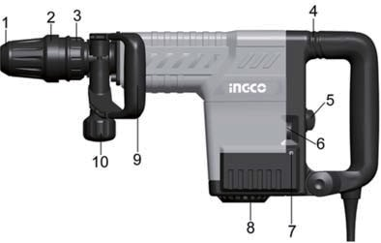

1. Hammer rod protector
2. Protective lining
3. Move limited ring
4. Anti-vibration System
5. Switch
6. Speed Adjuster Function Knob
7. Indicator
8. Fan cover
9. Side Handle
10. Function Knob

**Prior to operation**

1. Power source

Ensure that the power source to be utilized conforms to the power requirements which specified on the name plate of the hammer.

1. Power switch

Ensure that the power switch is in the position of OFF. If the plug is connected to power receptacle while the power switch is in ON position, the demolition hammer will start operation immediately, which can cause serious accident.

1. Extension cord

When the work area is removed from the power source, use an extension cord of sufficient thickness and rated capacity. The extension cord should be kept as short as practicable.

# Assembly

### Auxiliary Handle

**Operate your power tool only with the** Side Handle **9.**

The Side Handle 9 can be set to any position for a secure and low-fatigue working posture.

Loosen the Function Knob 10, rotate the Side Handle 9 around the axis of the power tool to the required position and tighten the Function Knob 10 again.

The Side Handle **9** can be mounted to a different position. For this, completely unscrew the Function Knob 10 and then pull out the hexagon bolt upward. Pull off the Side Handle 9 to the side and turn around the remaining clamping element by 180。Mount the Side Handle 9 in reverse order.

### Changing the tool

###### Before any work on the power tool itself, pull the mains plug.

Tool holder. Simpler and easier tool changing is possible without additional aids.

The Hammer rod protector 1 largely prevents the entry of drilling dust into the tool holder during operation. When inserting the tool, take care that the Hammer rod protector 1 is not damaged.

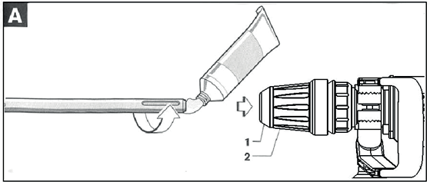**A damaged** Hammer rod protector **should be changed immediately.** We recommend having this carried out by an after-sales service.

###### Inserting (see figure A)

Clean and lightly grease the shank end of the tool.

Insert the tool in a twisting manner into the tool holder until it latches itself.

Check the latching by pilling the tool.

###### Removing (see figure B)

Push back the Protective lining **2** and remove the tool.

# Operation

### Starting Operation

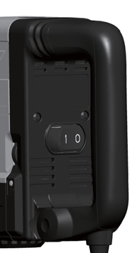**Observe correct mains voltage!** The voltage of the power source must agree with the voltage specified on the type plate of the power tool.

###### To start the power tool, Press the switch towards arrow “I” direction .

**To switch off the power tool, Press the switch towards arrow “0” direction.**

For low temperatures, the power tool reaches the full impact rate only after a certain time.

This start-up time can be shortened by striking the chisel in the power tool against the floor one time.

###### Setting the Impact Rate

The electronic control enables stepless speed preselection in accordance with the material to be worked. The constant electronic control keeps the preselected impact rate nearly constant between no-load and load conditions.

Select the impact rate with the Speed Adjuster Function Knob 10 according to the material. The data in the following table are recommended values.

|  |  |
| --- | --- |
| Speed Adjuster Function Knob 6 | Impact frequency(min-1) |
| 1 | 1000 |
| 2 | 1200 |
| 3 | 1350 |
| 4 | 1550 |
| 5 | 1750 |
| 6 | 1900 |

###### Changing the Chiselling Position (Vario-lock)

The chisel can be locked in 12 positions. In this manner, the optimum working position can be set for each application.

Insert the chisel into the tool holder.

Push the Move limited ring 3 forward and turn the chisel to the required position with the Move limited ring 3.

Release the Move limited ring 3 and turn the chisel until it latches.

###### Shock absorption Equipment 4

The TH215002 is equipped with an active vibration re duction system, which cuts vibration of that of the without Active Vibration Reduction. This may significantly reduce the exposure level over the total working period. protect the operator form the effects of vibration.

# Maintenance and Service

### Maintenance and cleaning

###### Before any work on the power tool itself, pull the mains plug.

**For safe and proper working, always keep the power tool and the ventilation slots clean.**

**A damaged** hammer rod protector should be changed immediately**.** We recommend having this carried out by an after-sales service.

###### Inspecting the drill bits

Use a dull accessory, such as bull point, cutter, etc., will cause motor malfunction and efficiency degraded. Replace with a new one when your accessory is abased.

1. Check all external parts of the tool for damage at regular intervals. Do not operate the tool if parts are damaged. If necessary, your power tool should be repaired at a INGCO authorized service center .

###### Inspecting the mounting screws

Regularly inspect all mounting screws and ensure that they are properly tightened. Any loose should be tighten immediately, failure to do maybe cause serious hazard.

###### Indicator 7

When the carbon brushes are worn out, the power tool switches itself off. This is indicated beforehand by the lighting or blinking of the indicator 7. The power tool must then be sent to an after-sales service agent. If the power tool should fail despite the care taken in manufacturing and testing procedures, repair should be carried out by an after-sales service center for INGCO power tools.

### Warranty

For the condition of warranty, please refer to the separately provided warranty card.

### Environment

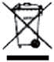Faulty and /or discarded electrical or electronic apparatus have to be collected at the appropriate recycling location.

###### NOTE:

Due to INGCO’S continuing program of research and development, the specificationsherein are subject to change without prior notice.

**PDB15006,PDB15006,UPDB15006,PDB15006-4,PDB15006M PDB15006-6,PDB15006-8,PDB15006-9,PDB15006S**

***EXPLODED VIEW***

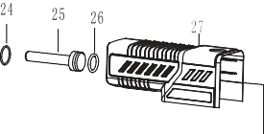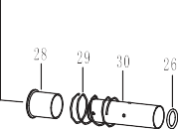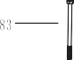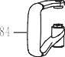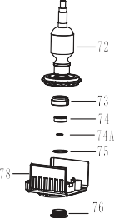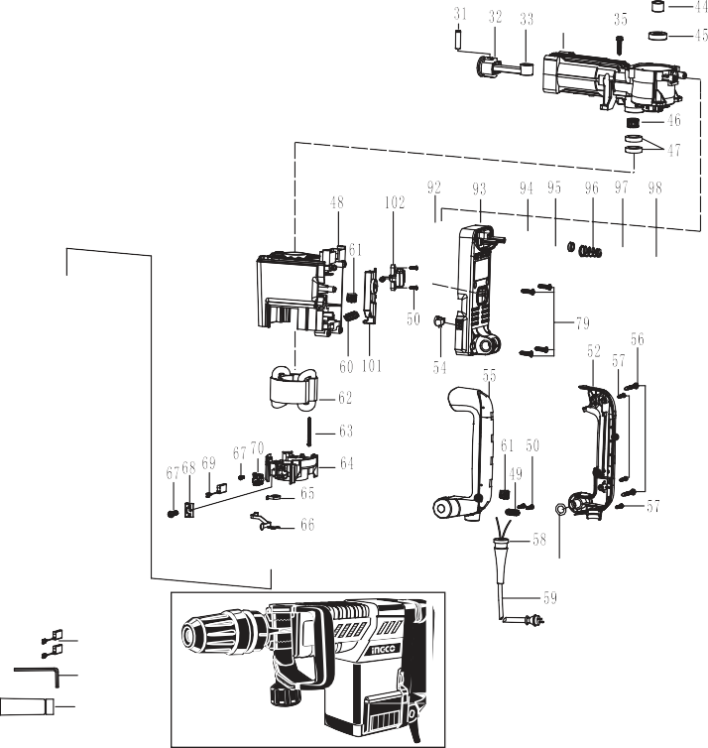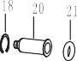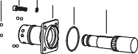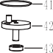

***SPARE PART LIST***

**PDB15006,PDB15006,UPDB15006,PDB15006-4,PDB15006M PDB15006-6,PDB15006-8,PDB15006-9,PDB15006S**

|  |  |  |  |  |  |  |
| --- | --- | --- | --- | --- | --- | --- |
| 30 | Cylinder | 1 |  | 65 | Helical spring | 2 screws M6×50( 18) |
| 31 | Piston Pin 10×38 | 1 |  | 66 | Metal contact plate | 99 O-Ring 16× 3 2  1 |

|  |  |  |  |  |  |  |  |  |  |  |
| --- | --- | --- | --- | --- | --- | --- | --- | --- | --- | --- |
| **No.** | **Part Description** | **Qty** |  | **No.** | **Part Description** | **Qty** |  | **No.** | **Part Description** | **Qty** |
| 1 | Hammer rod protector | 1 |  | 34 | Impact body | 1 |  | 68 | Metal insert | 2 |
| 2 | Protective lining | 1 |  | 35 | Tapping screw ST6.3X32 | 4 |  | 69 | Carbon Brush | 2 |
| 3 | 30 Retaining Ring | 1 |  | 36 | Oil Tank Cover | 1 |  | 70 | Carbon brush wire | 2 |
| 4 | Support patch | 1 |  | 37 | Rubber Washer 31 25 2.2 | 1 |  | 72 | Armature 220-240V | 1 |
| 5 | Shock absorption ring | 1 |  | 38 | Felt Ring | 1 |  | 72 | Armature 110-120V | 1 |
| 6 | Move limited ring | 1 |  | 39 | Hex .Socket Bolt M5×12 12.9 | 4 |  | 73 | Bearing Sleeve | 1 |
| 7 | Insert block | 2 |  | 40 | Shell cover | 1 |  | 74 | 6200 DD Ball Bearing | 1 |
| 8 | Change plate | 1 |  | 41 | O-Ring 79× 2.8 | 1 |  | 74A | 10 Retaining Ring | 1 |
| 9 | Support ring spring | 1 |  | 42 | Eccentric gear subassembl | 1 |  | 75 | O-Ring 30× 2 | 1 |
| 10 | Support ring | 1 |  | 43 | 6002 DD Ball Bearing | 1 |  | 76 | Screw ring | 1 |
| 11 | Move limited ring | 1 |  | 44 | Distance Ring | 1 |  | 77 | Protected cover | 1 |
| 12 | 6.5 Steel Ball | 8 |  | 45 | 6002 RS Ball Bearing | 1 |  | 78 | Bearing Cover | 1 |
| 13 | Hex. Socket Bolt M8×30(12.9) | 4 |  | 46 | Needle Bearing NK20×28×13 | 1 |  | 79 | Tapping screw ST5.5X25 | 8 |
| 13A | 8 Spring Washer | 4 |  | 47 | Seal ring subassembly | 2 |  | 80 | Disk with gap | 2 |
| 14 | Flange cover | 1 |  | 48 | Housing Ass'y | 1 |  | 81 | Clamping | 2 |
| 15 | O-Ring 63.5× 2.6 | 1 |  | 49 | Cord Clip | 1 |  | 82 | Fixed belt | 1 |
| 16 | Hammer rod sleeve | 1 |  | 50 | ST4.2×18 Tapping Screw | 4 |  | 83 | Hexagon head bolt M8×130 | 1 |
| 17 | Fluorin O Ring 31.6× 2.5 | 1 |  | 52 | Main Handle Cover | 1 |  | 84 | Side Handle | 1 |
| 18 | 41 Retaining Ring | 2 |  | 54 | Indicator | 1 |  | 85 | Function Knob | 1 |
| 19 | Oil Seal Ring 32× 42×7 | 1 |  | 55 | Main Handle | 1 |  | 86 | Nut M8(Thickness 6.4mm) | 1 |
| 20 | Impact Pin | 1 |  | 56 | ST5.5×45 Tapping Screw | 2 |  | 87 | Function Knob cover | 1 |
| 21 | Fluorin O Ring 22× 11 | 1 |  | 57 | ST4.2×22 Tapping Screw | 3 |  | 88 | 10mm Hex Bar Wrench | 1 |
| 22 | Control plate | 1 |  | 58 | Cord Armor | 1 |  | 91 | Oil Bottle 35×135 | 1 |
| 23 | Fixed Distance Sleeve | 1 |  | 59 | Cord | 1 |  | 92 | Fixed Platen | 1 |
| 24 | O-Ring 35× 3 | 1 |  | 60 | 0.18 H Electricity Feels | 1 |  | 93 | Main Handle Seat | 1 |
| 25 | Impact block | 1 |  | 61 | Rivet | 4 |  | 94 | Shock Absorption Jacket | 1 |
| 26 | Fluorin O Ring 30.4× 5 | 2 |  | 62 | Stator 220-240V | 1 |  | 95 | Shock Absorption Ferrule | 2 |
| 27 | Cover | 1 |  | 62 | Stator 110-120V | 1 |  | 96 | Shock Absorption Spring | 1 |
| 28 | Control Sleeve | 1 |  | 63 | ST4.8×58 Tapping Screw | 2 |  | 97 | Spring Rack | 1 |
| 29 | Control Sleeve Spring | 1 | | 64 | Carbon Brush bracket | 1 98 Cross recessed pan head 2 | | | | |

101 Speed Adjuster 1

|  |  |  |
| --- | --- | --- |
| 32 | Piston | 1 67 Cross recessed pan head 5 |
| 33 | Connecting Rod Ass’y | 1 screws ST3.5x14 102 Switch Subassembly 1 |

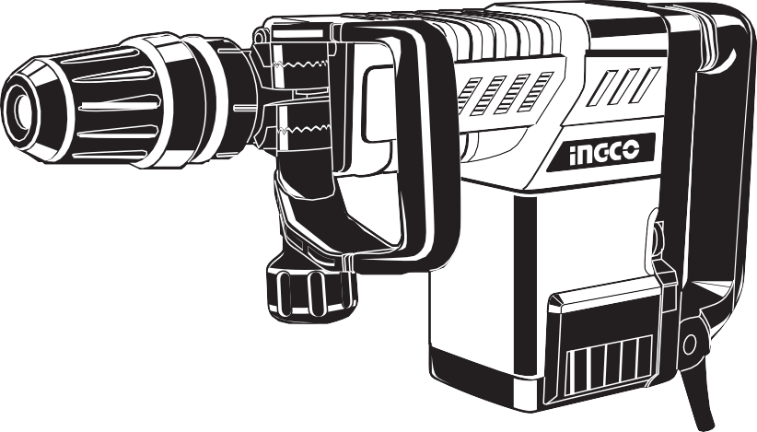

**INGCO TOOLS CO.,LIMITED**

[**www.ingco.com**](http://www.ingco.com/)

**MADE IN CHINA 0119.V08**

***PDB15006 PDB15006M UPDB15006 PDB15006-4 PDB15006-9 PDB15006-6 PDB15006S PDB15006-8***